1. 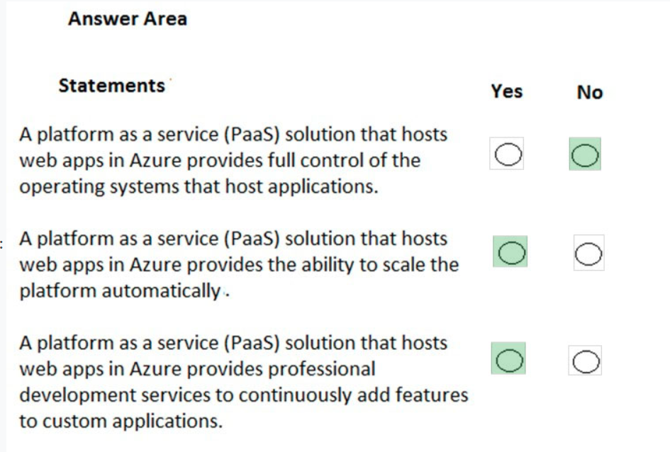
2. 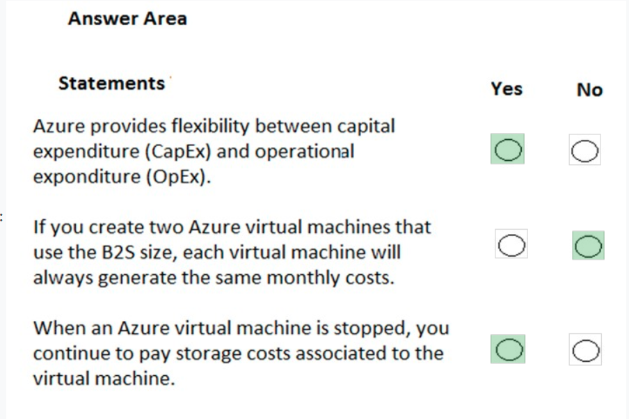
3. 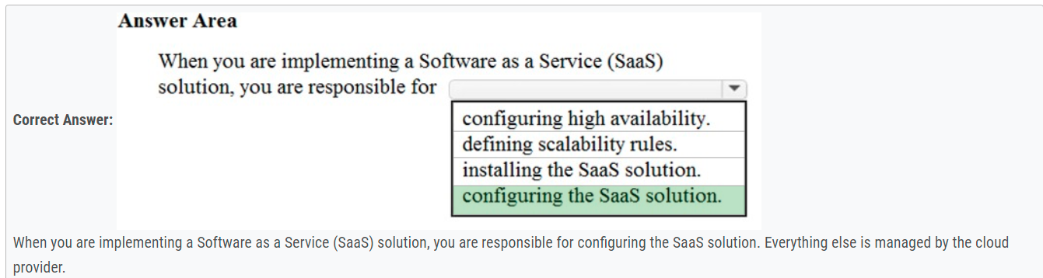
4. 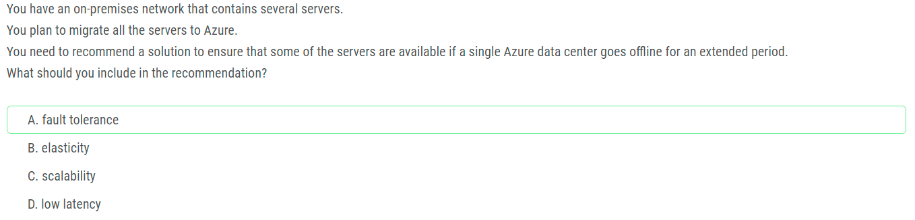
5. 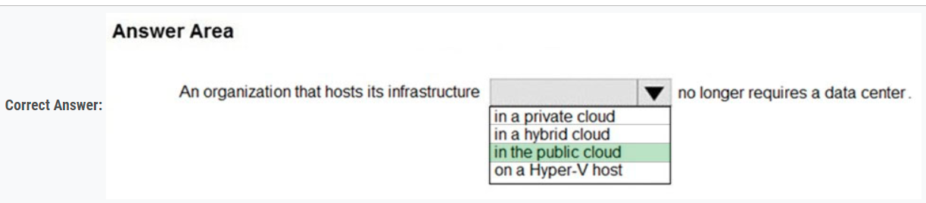
6. 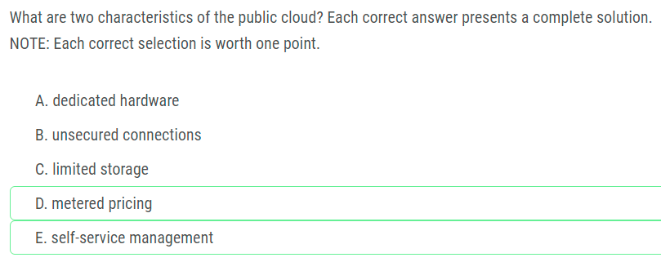
7. 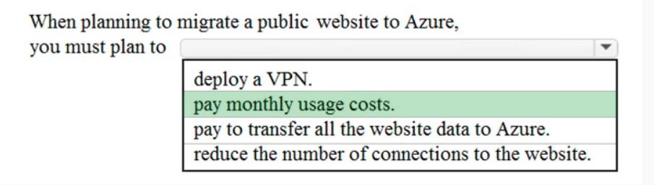

1. 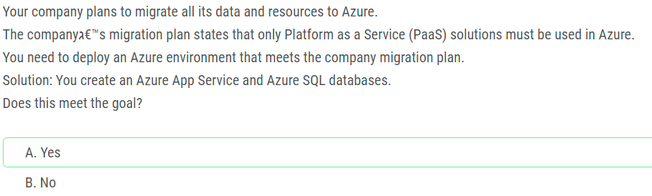

1. 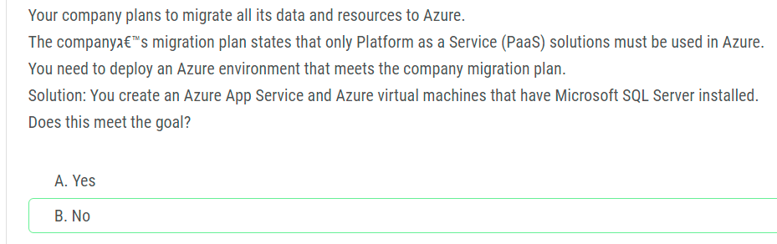
2. 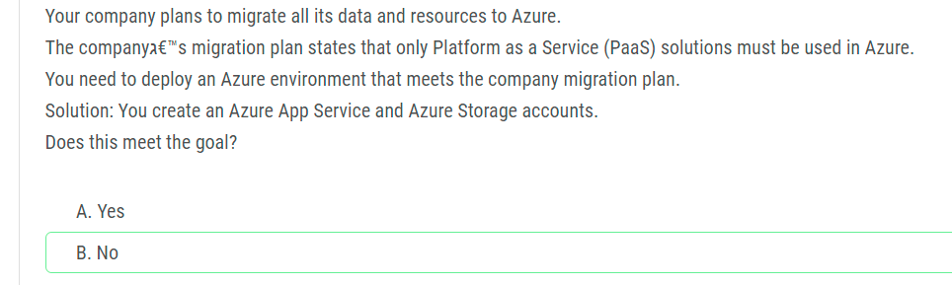
3. 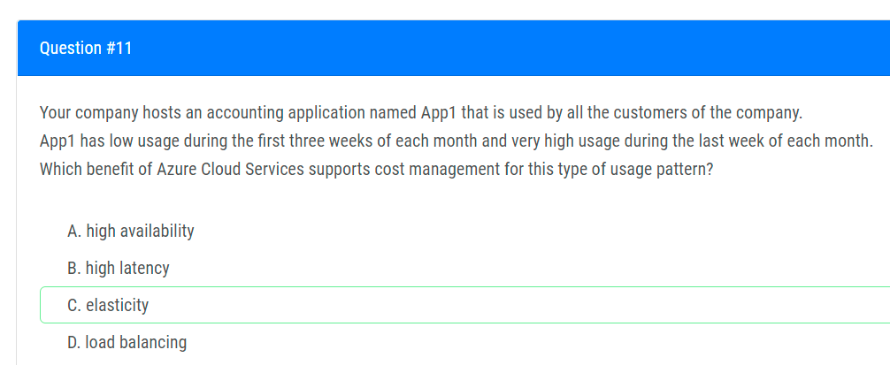
4. 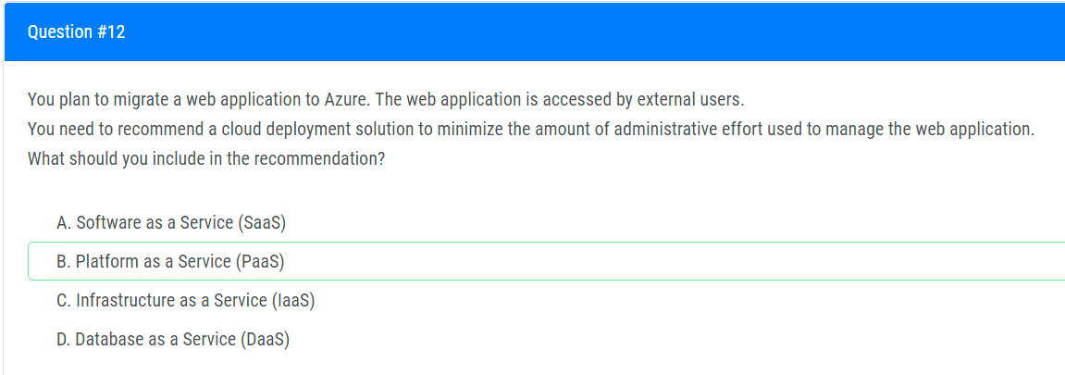
5. 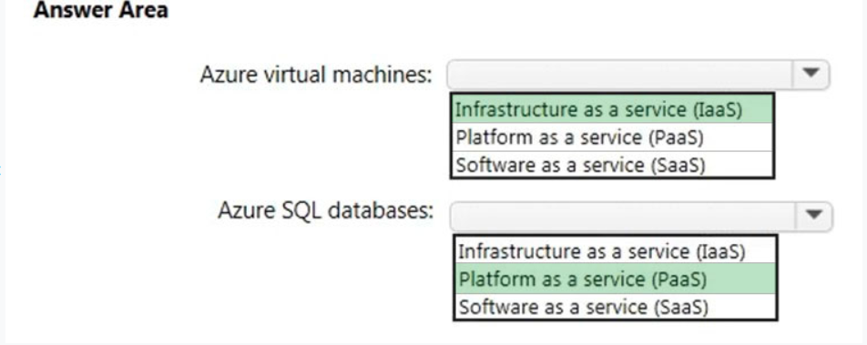
6. 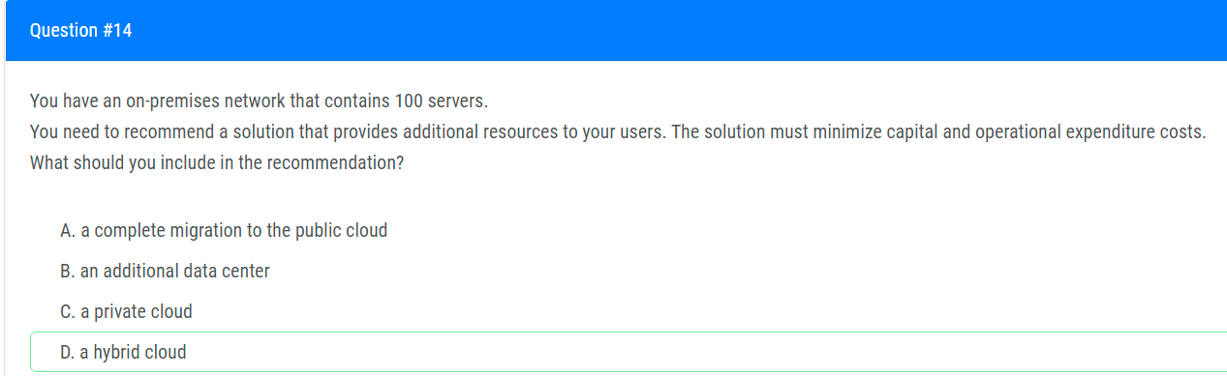
7. 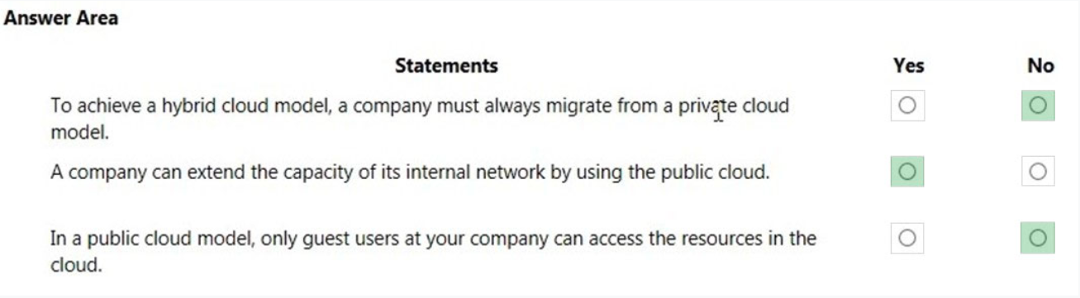
8. 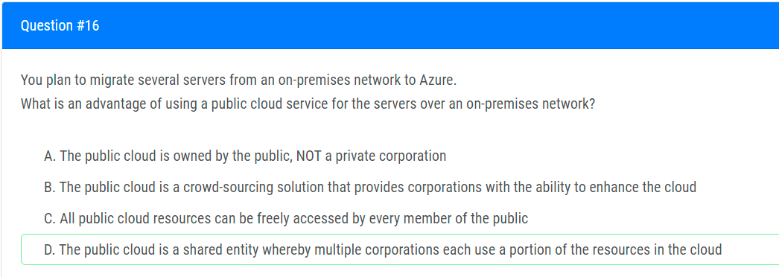
9. 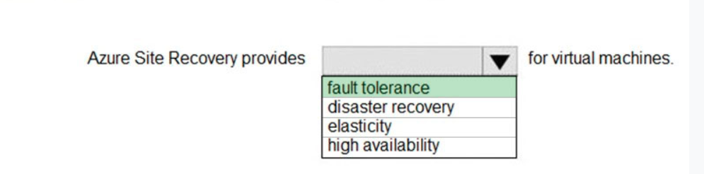
10. 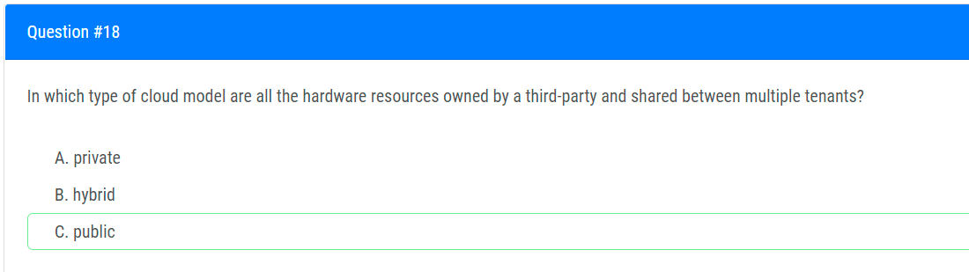
11. 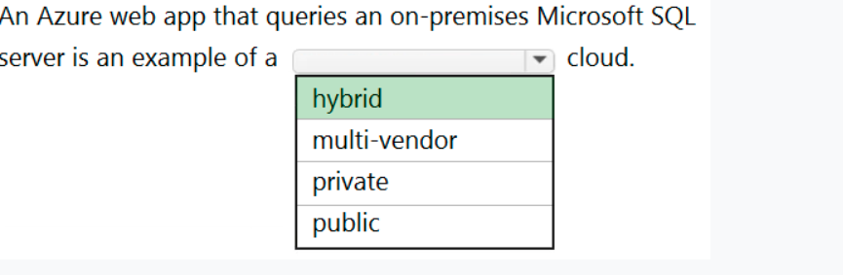
12. 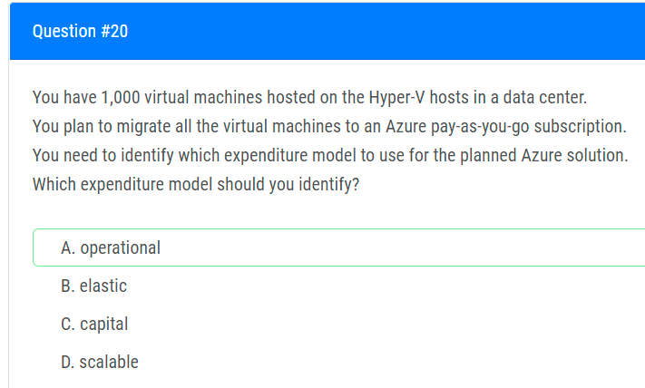
13. 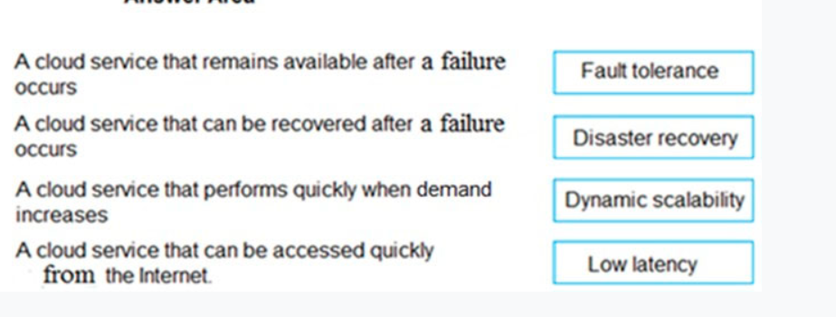
14. 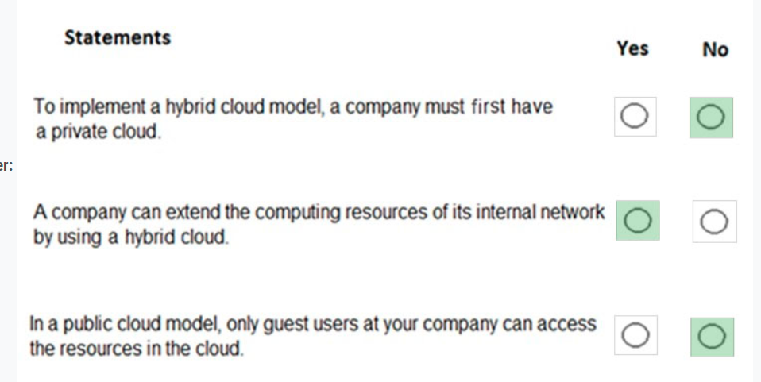
15. 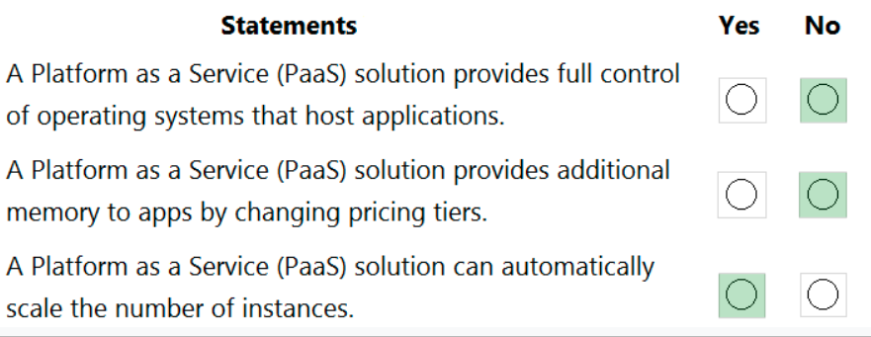
16. 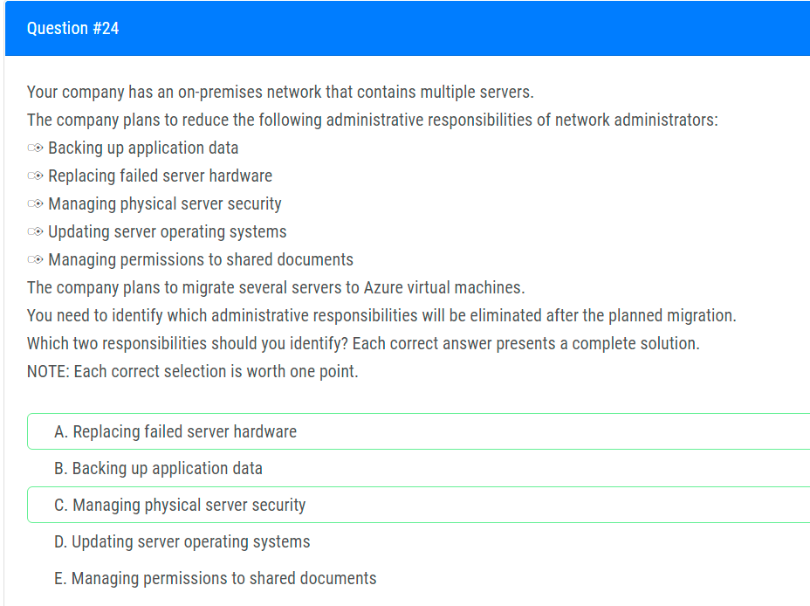
17. 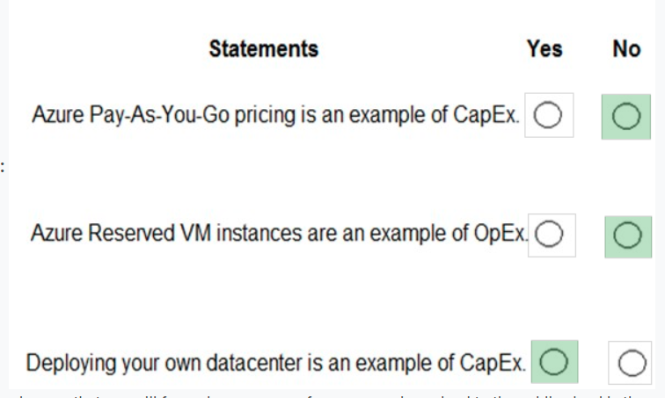
18. 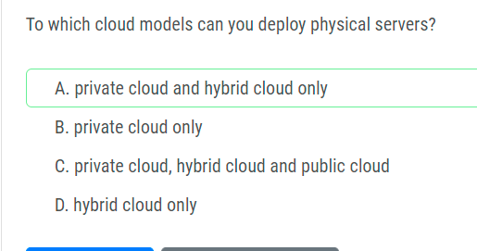
19. 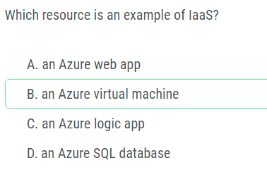
20. 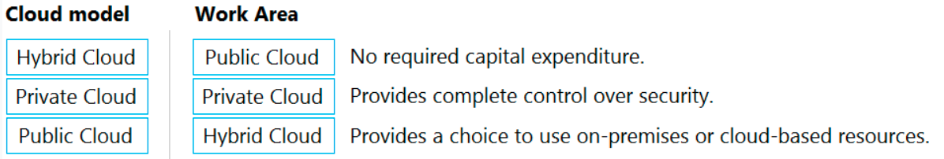
21. 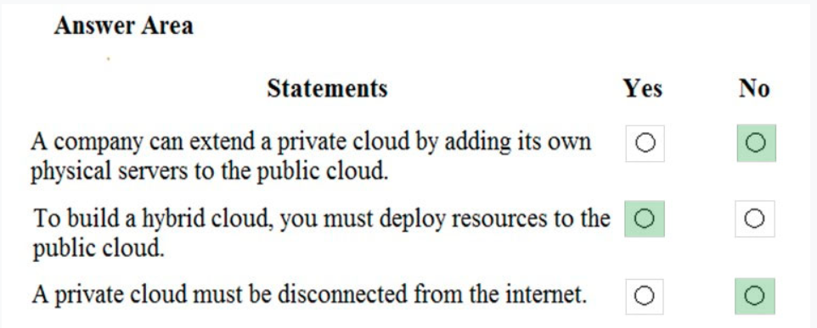
22. 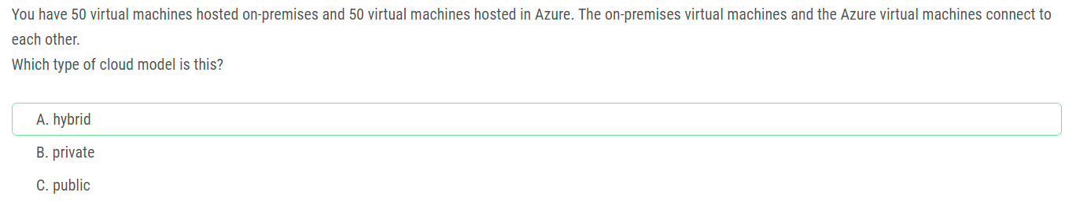
23. 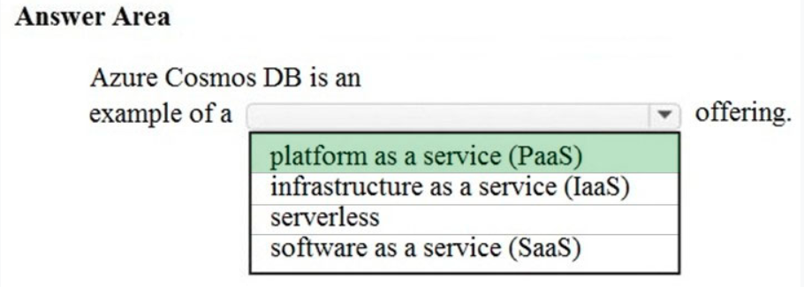
24. 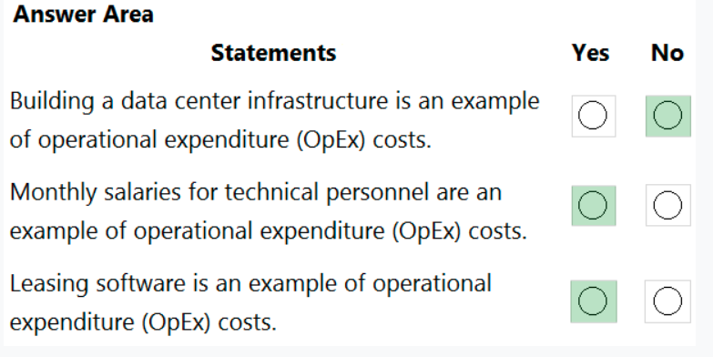
25. 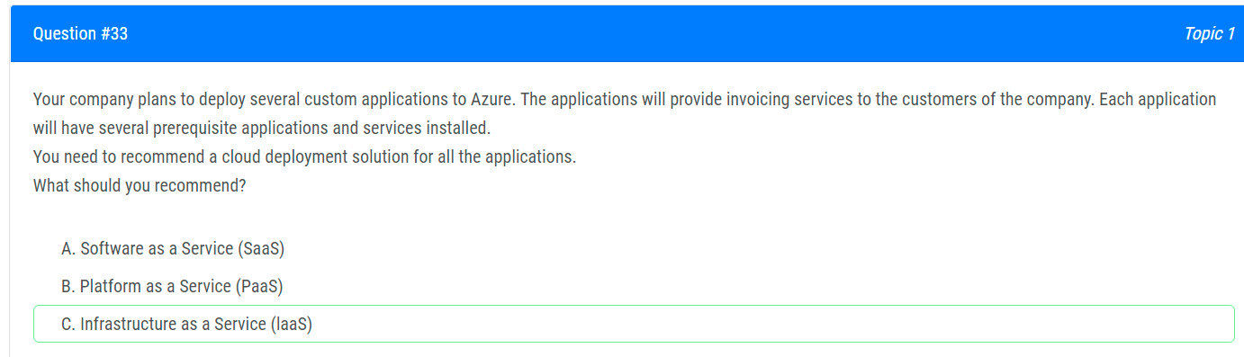
26. 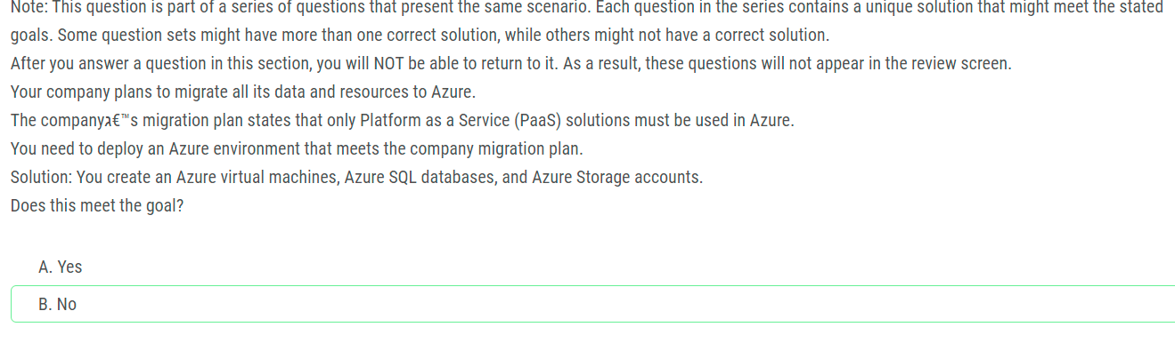
27. 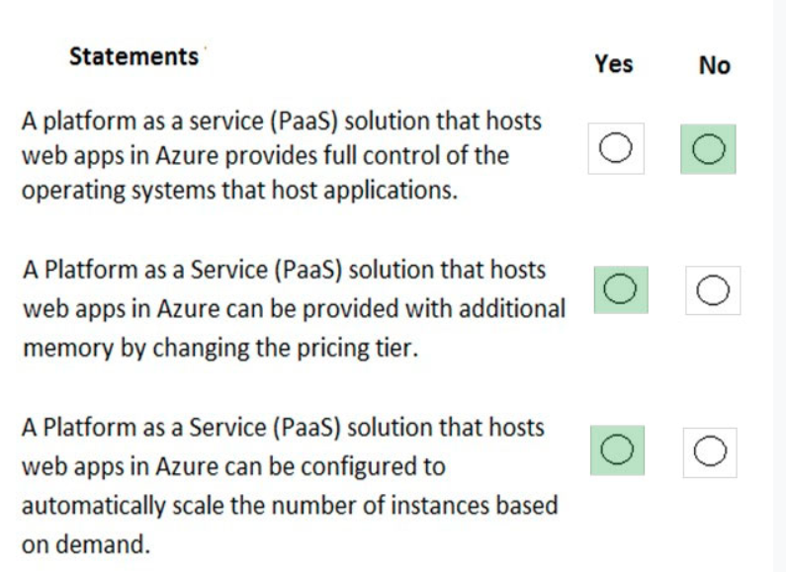
28. 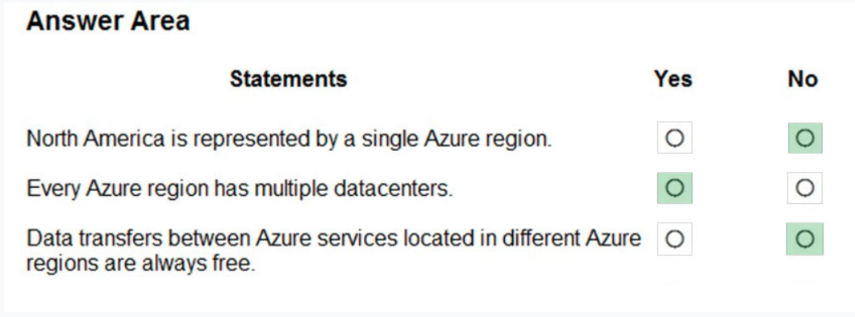
29. 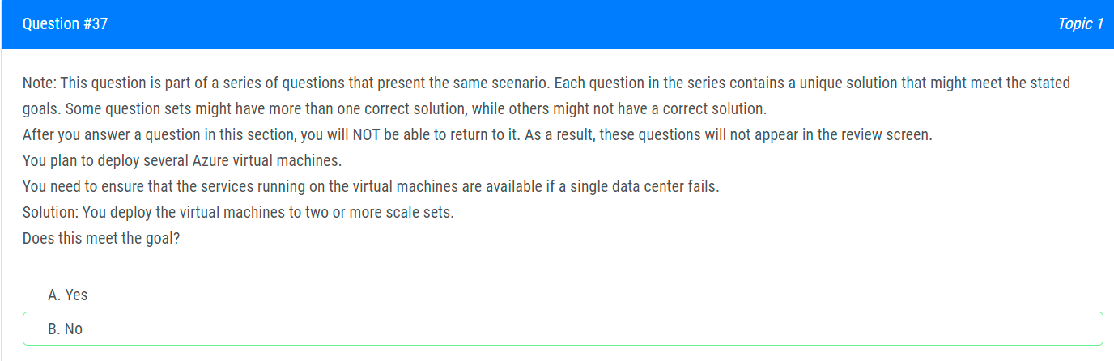
30. 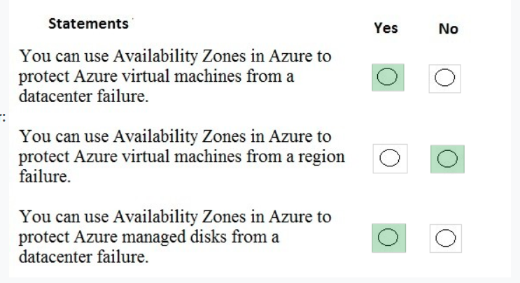
31. 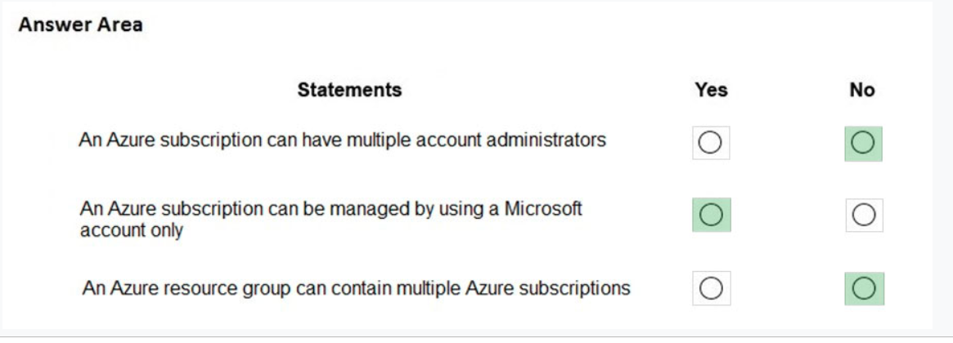
32. 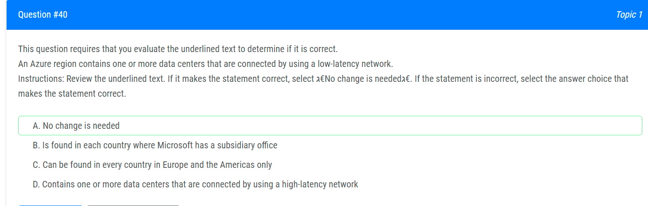
33. 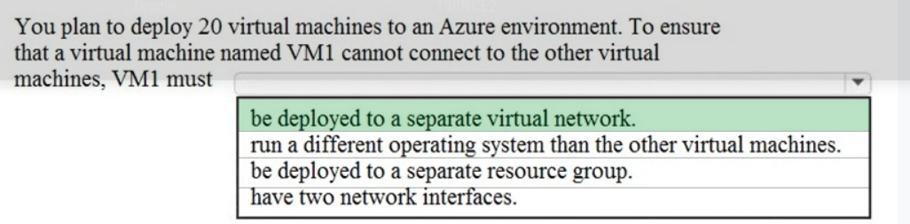
34. 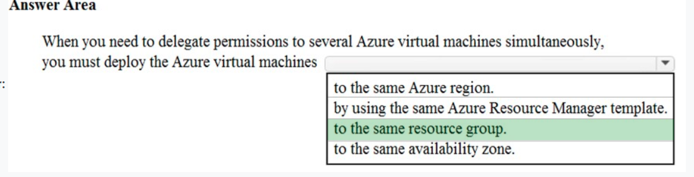
35. 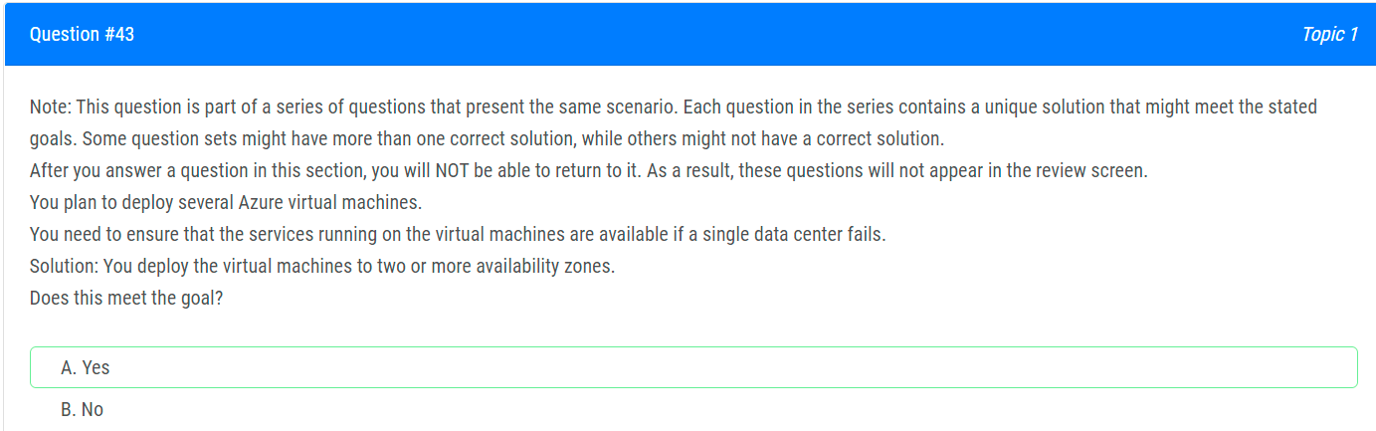
36. 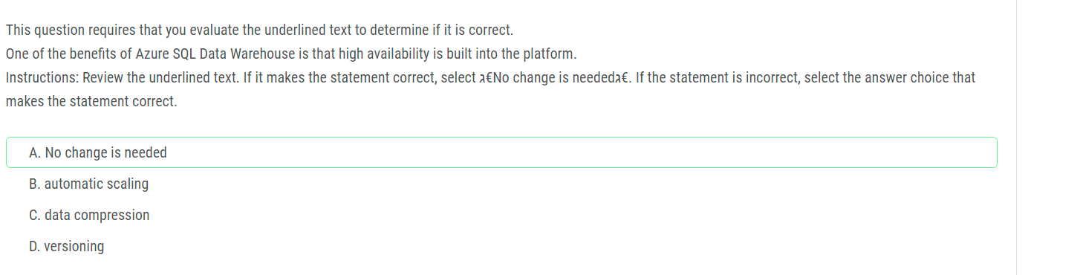
37. 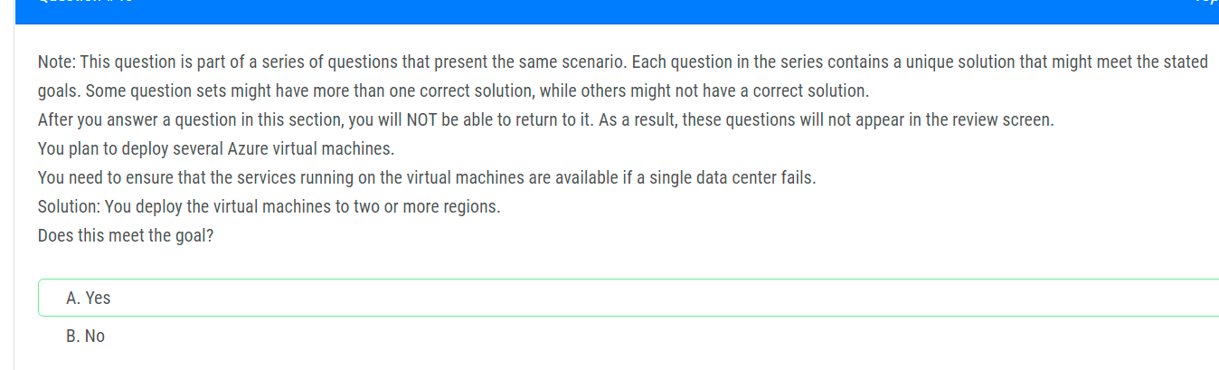
38. 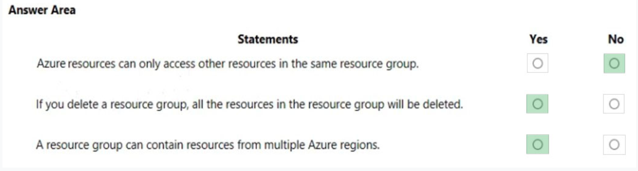
39. 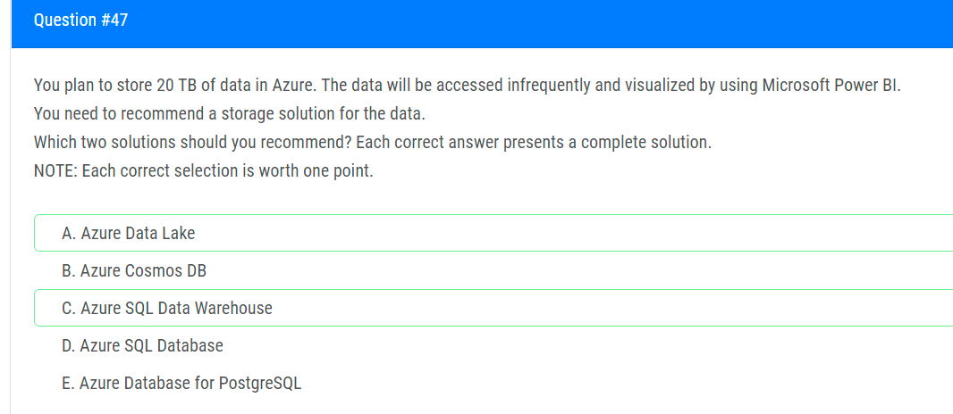
40. 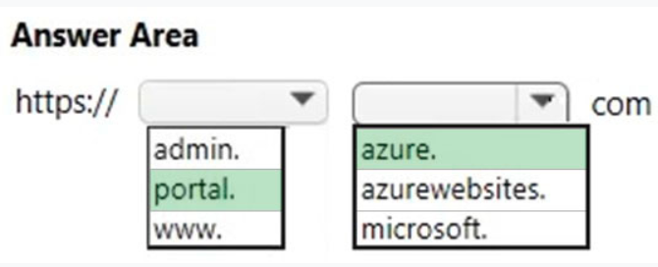
41. 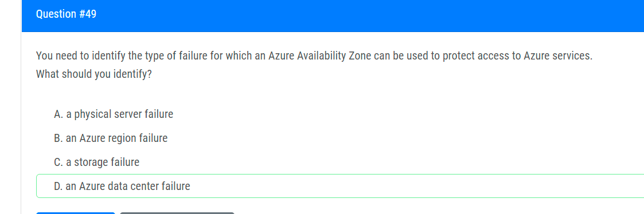
42. 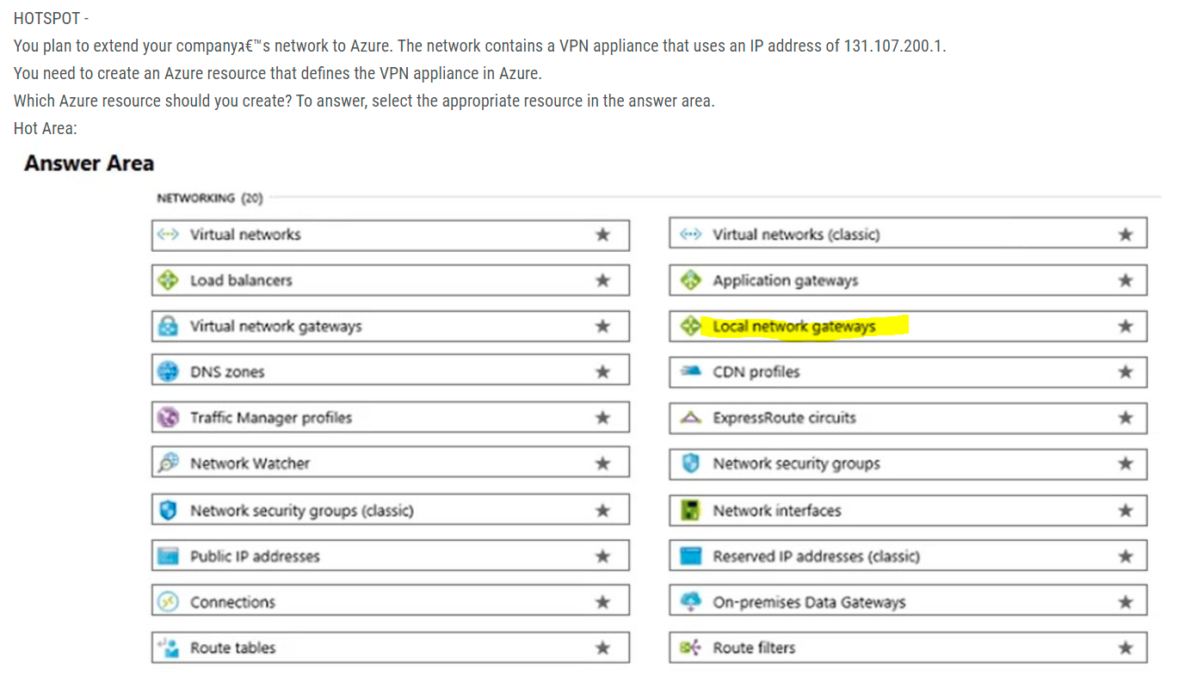
43. 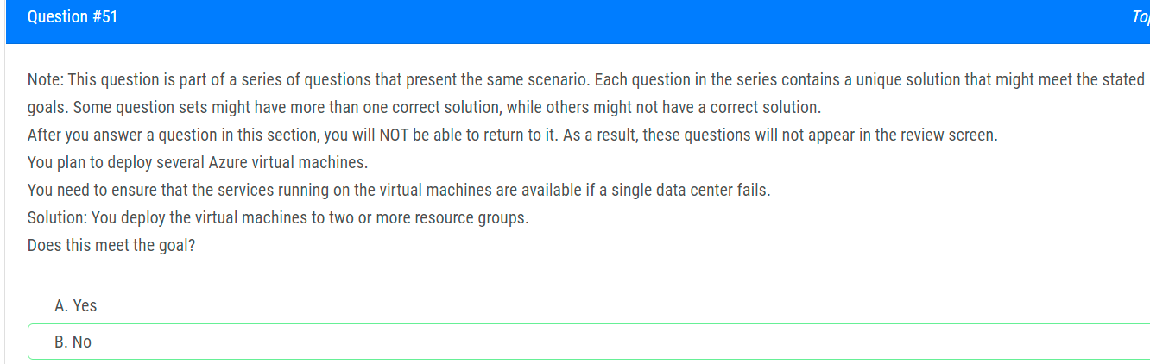
44. 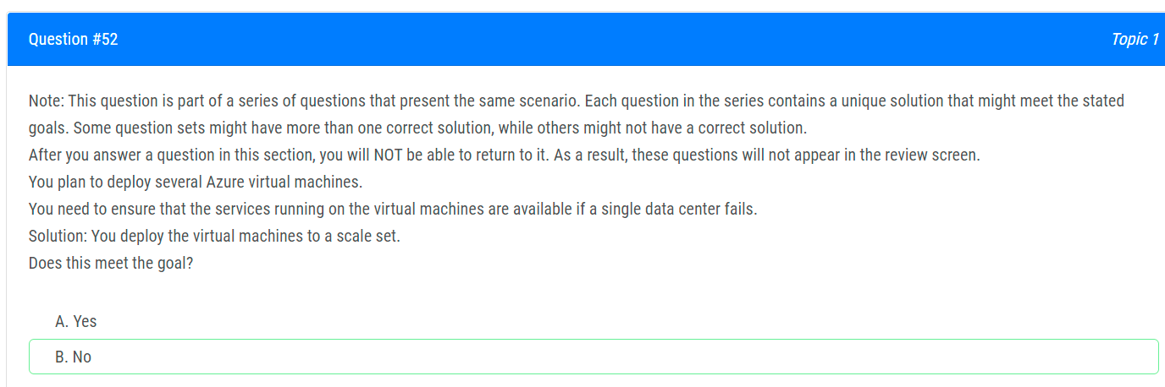
45. 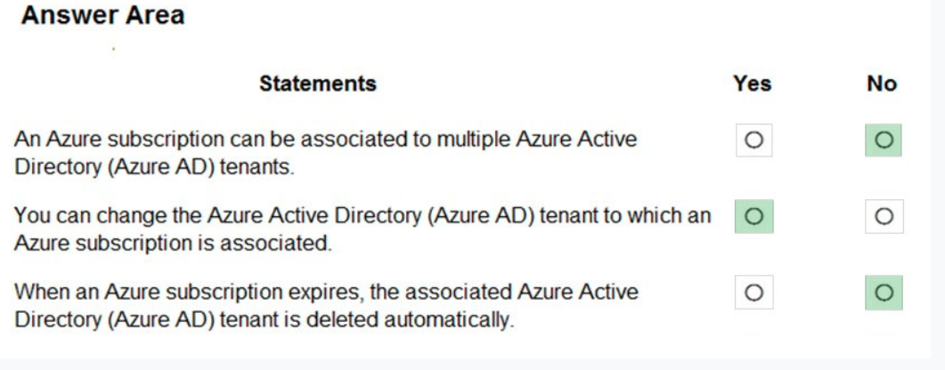
46. 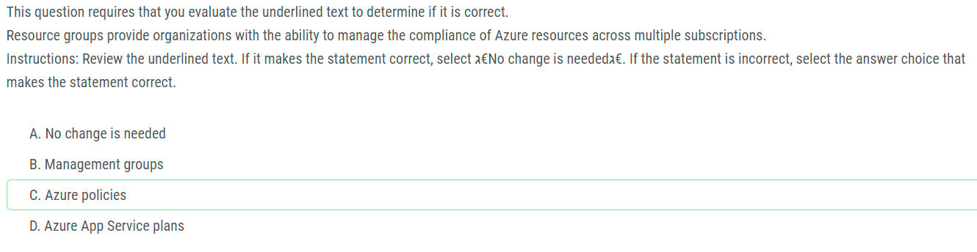
47. 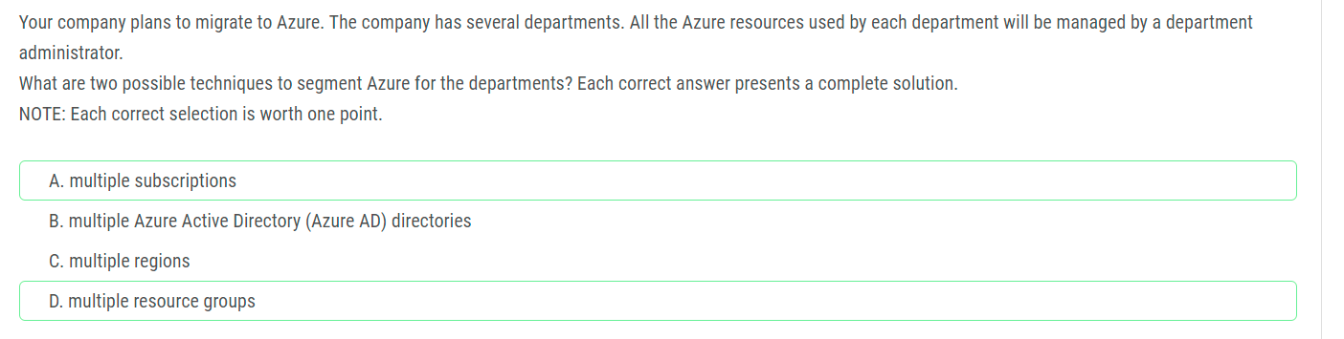
48. 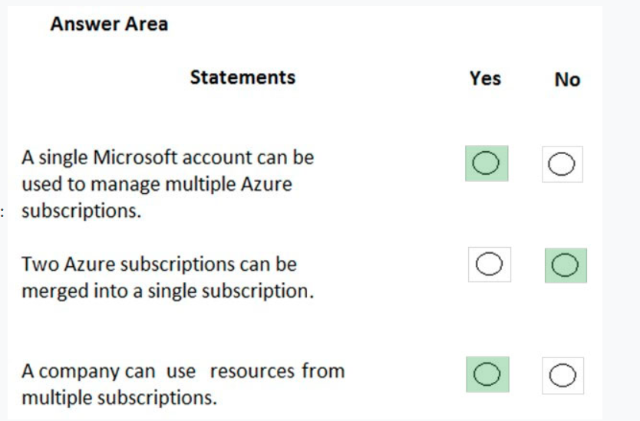
49. 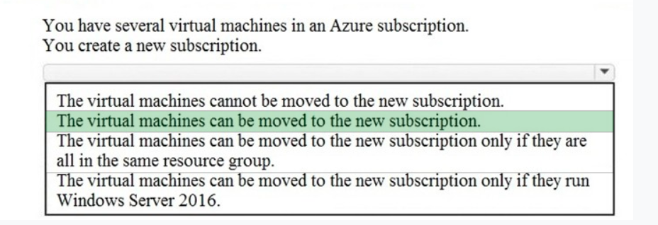
50. 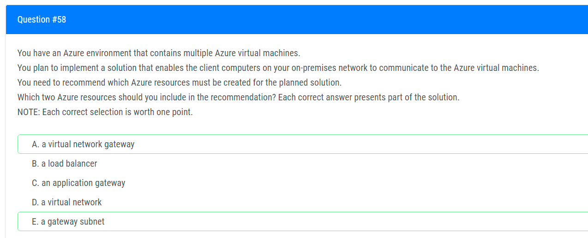
51. 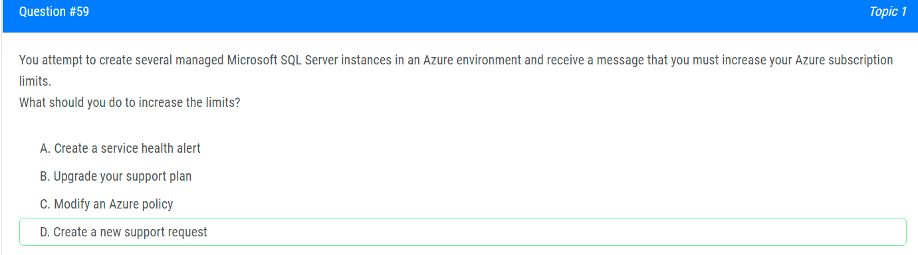
52. 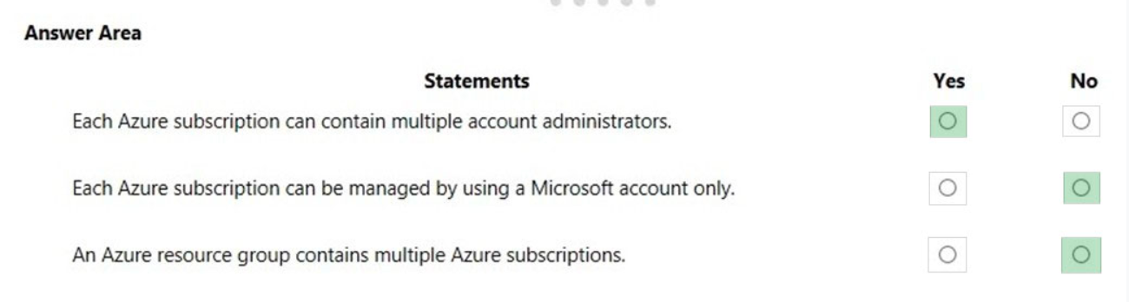(check 60 and 39)4
53. 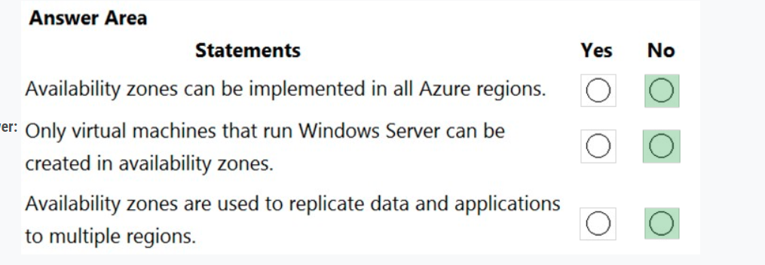
54. 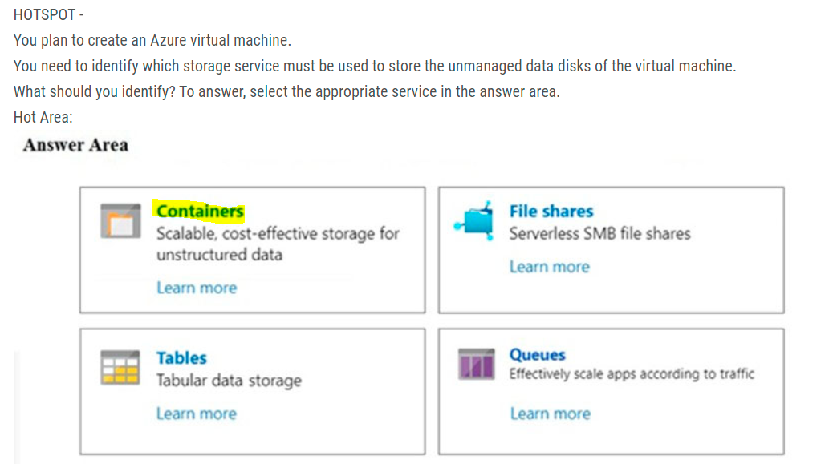
55. 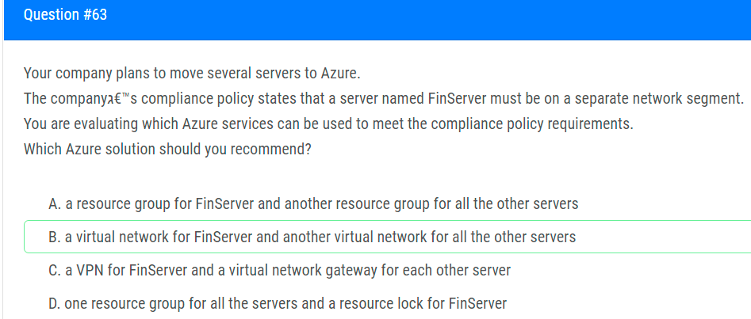
56. 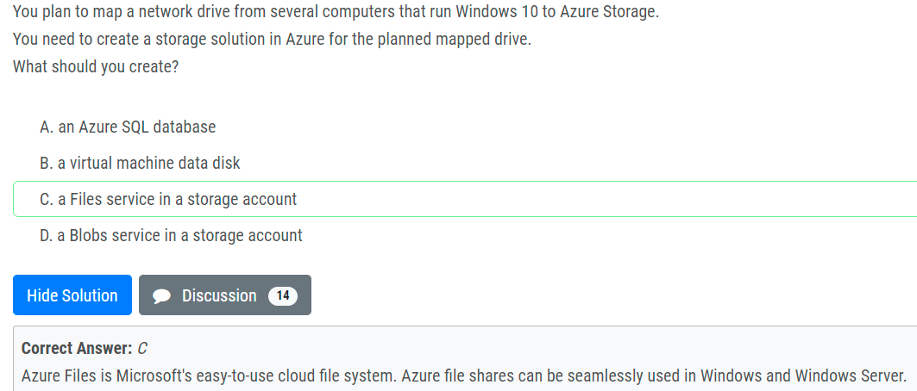
57. 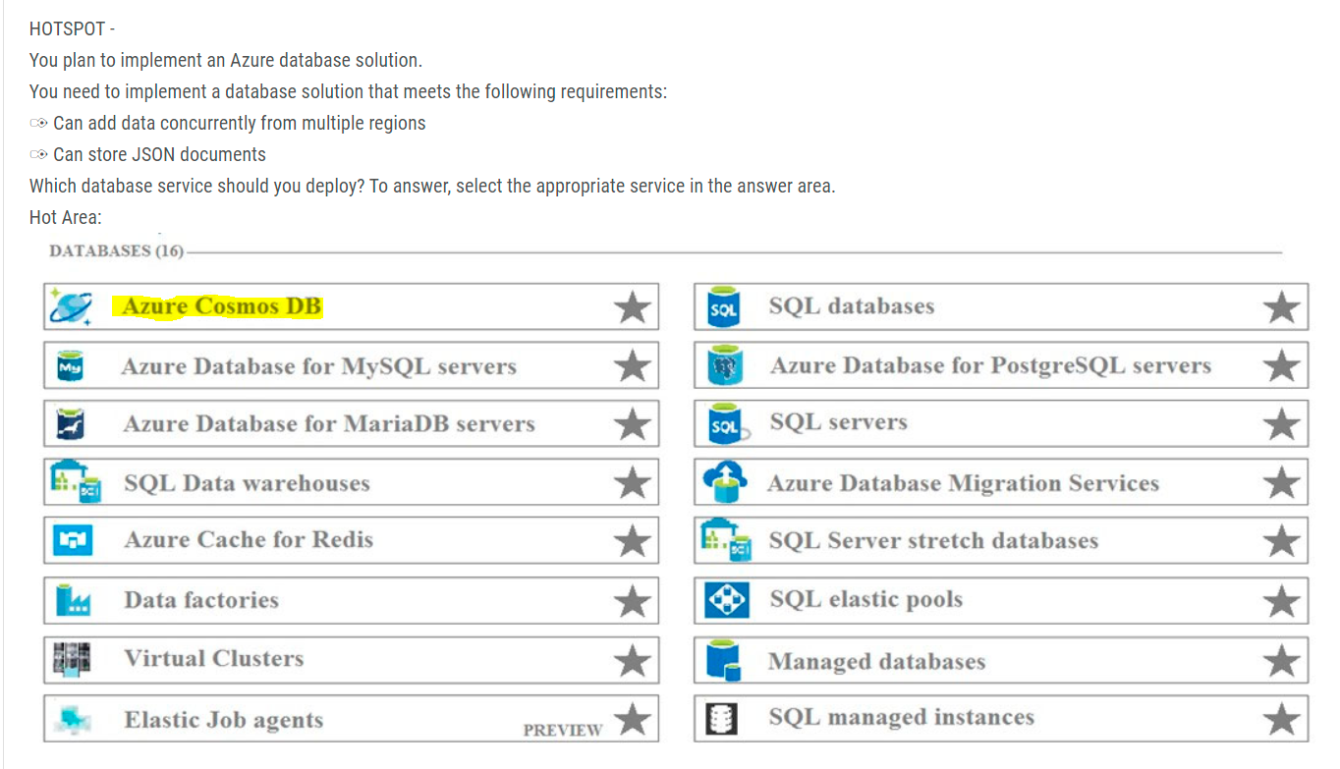

Azure Cosmos DB is Microsoft's globally distributed, multi-model database service. With a click of a button, Cosmos DB enables you to elastically and independently scale throughput and storage across any number of Azure regions worldwide.  
Azure Cosmos DB is a great way to store unstructured and JSON data. Combined with Azure Functions, Cosmos DB makes storing data quick and easy with much less code than required for storing data in a relational database.  
References:  
https://docs.microsoft.com/en-us/azure/cosmos-db/introduction <https://docs.microsoft.com/en-us/azure/azure-functions/functions-integrate-store-unstructured-data-cosmosdb?tabs=csharp>

1. 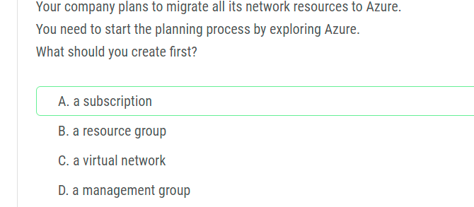
2. 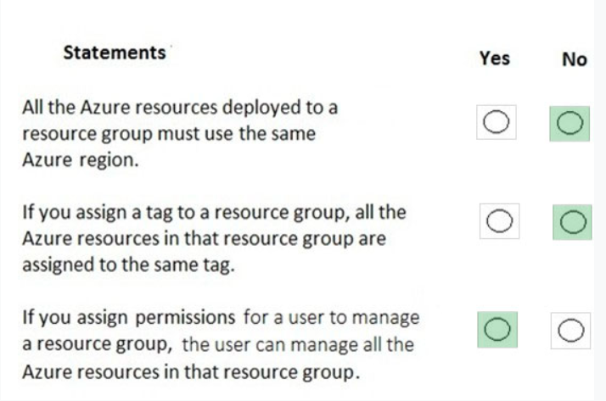
3. 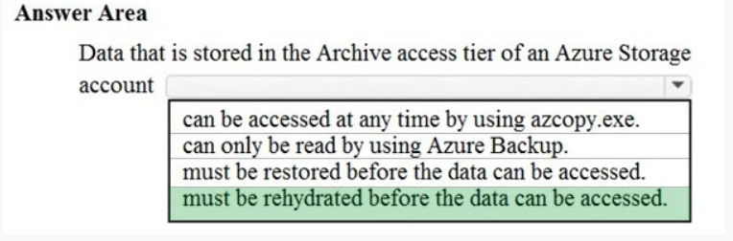
4. 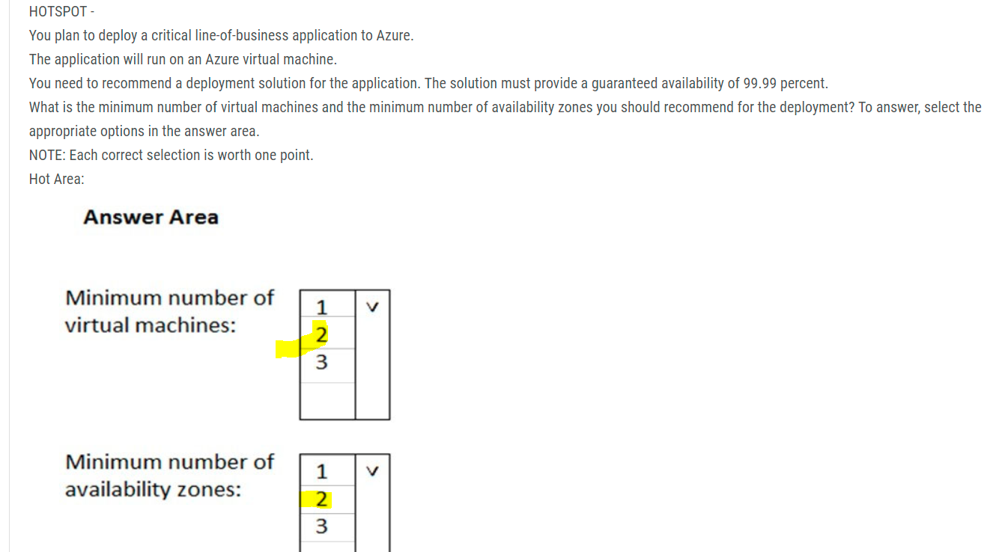
5. 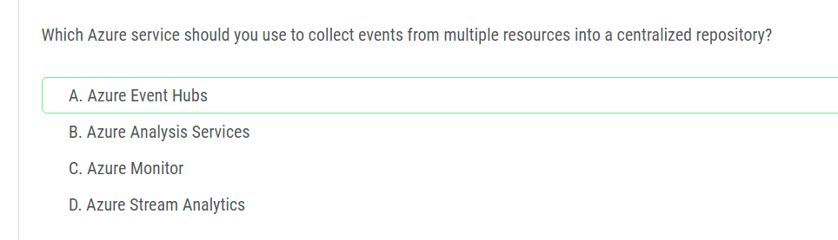
6. 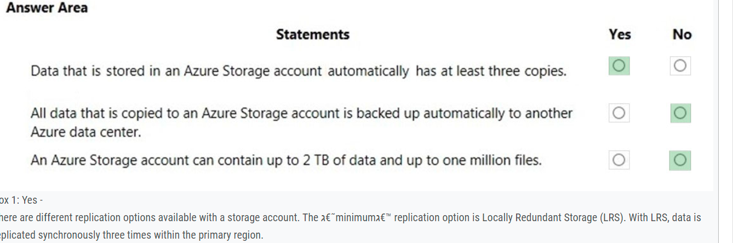
7. 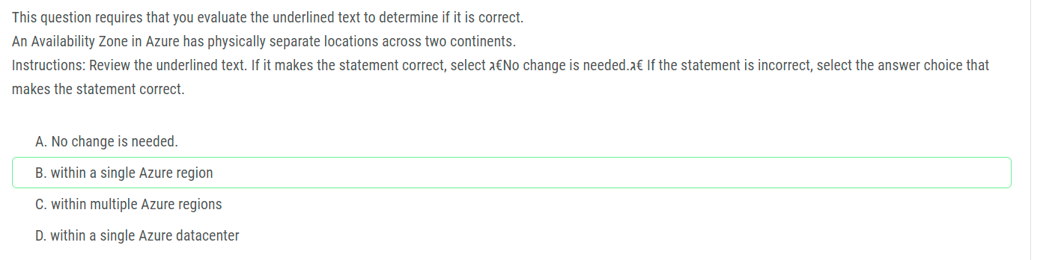
8. 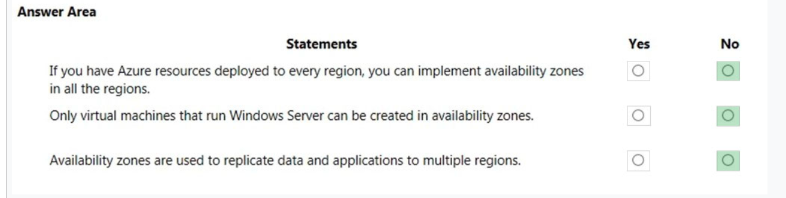
9. 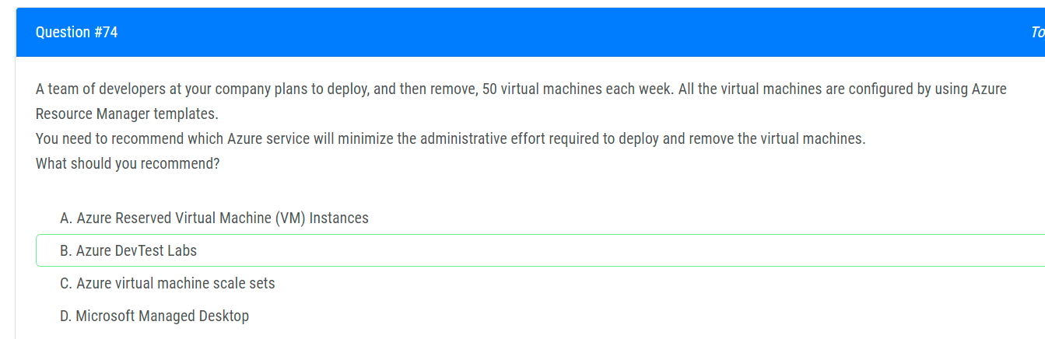DevTest Labs creates labs consisting of pre-configured bases or Azure Resource Manager templates.  
   By using DevTest Labs, you can test the latest versions of your applications by doing the following tasks:  
   ✑ Quickly provision Windows and Linux environments by using reusable templates and artifacts.  
   ✑ Easily integrate your deployment pipeline with DevTest Labs to provision on-demand environments.  
   ✑ Scale up your load testing by provisioning multiple test agents and create pre-provisioned environments for training and demos.
10. 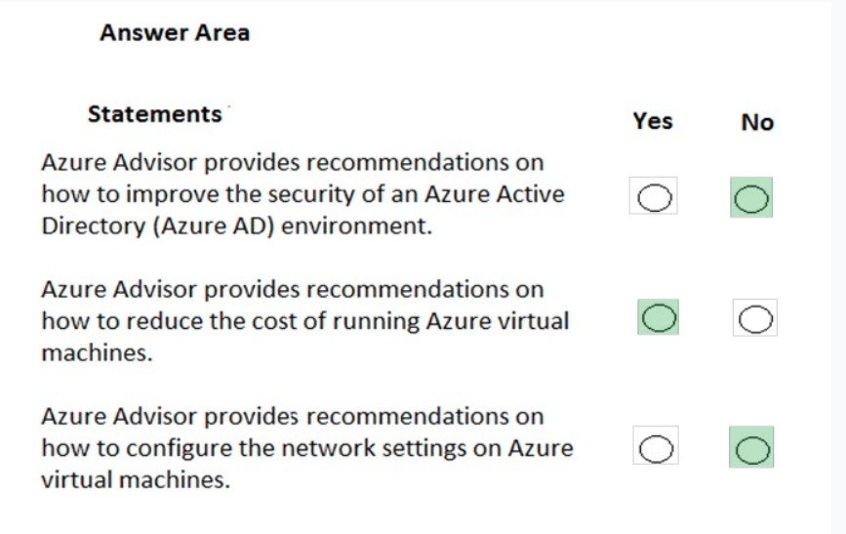
11. 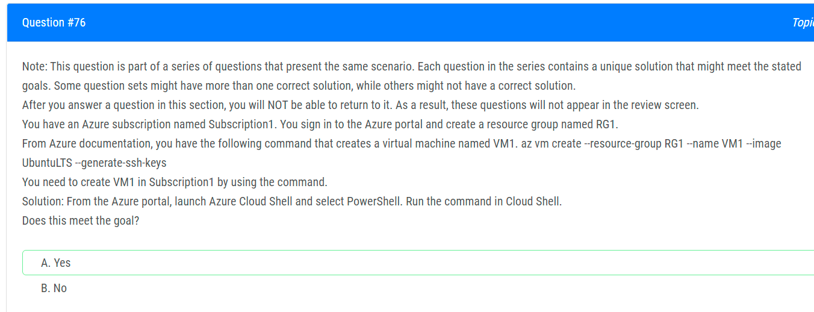
12. 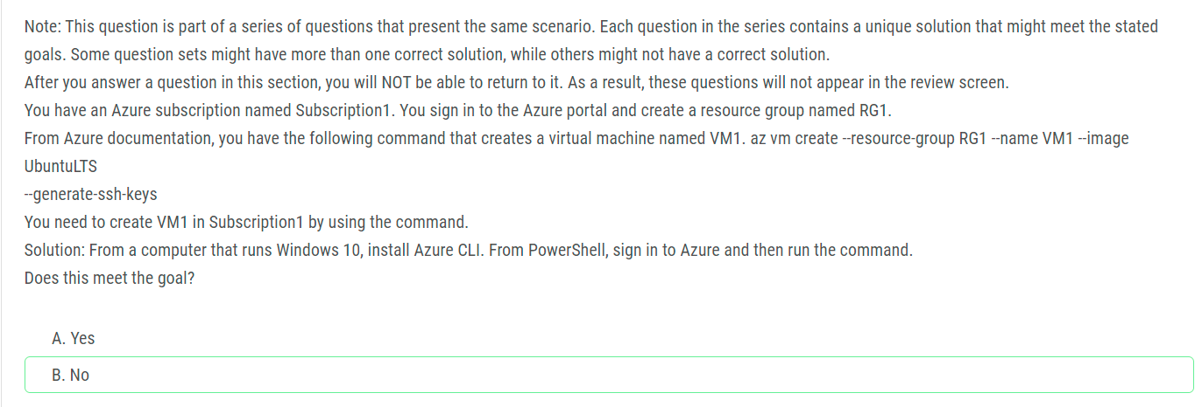
13. 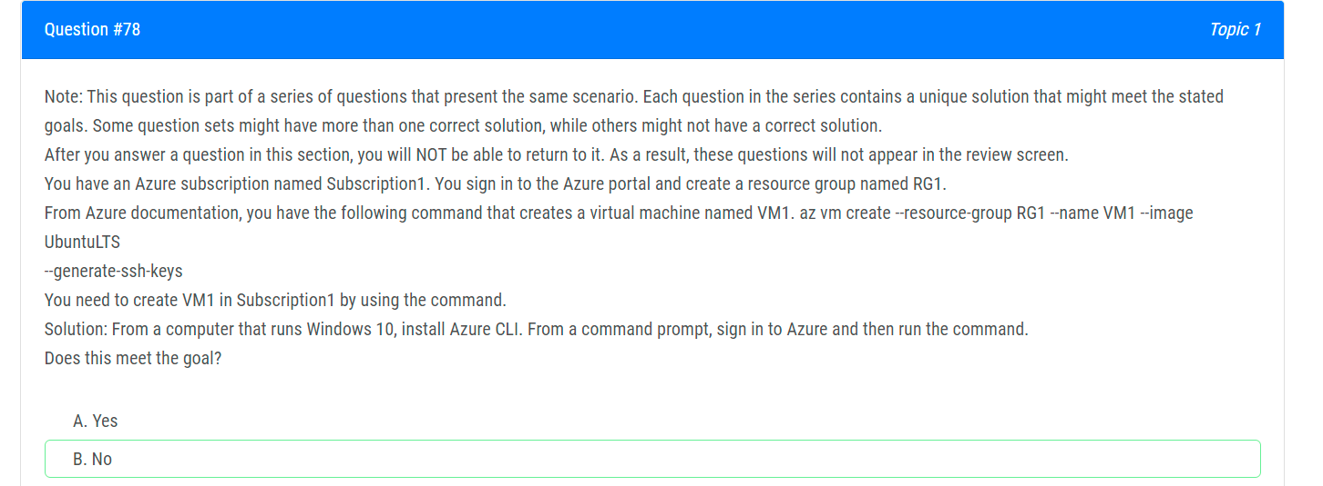
14. 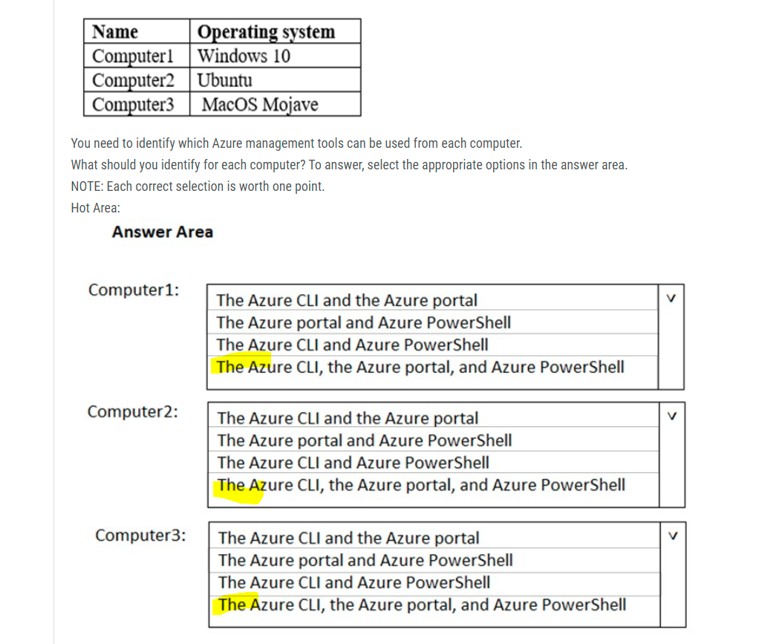
15. 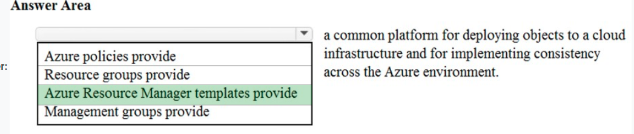
16. 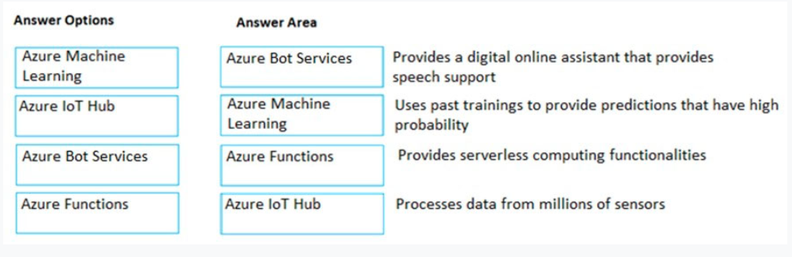
17. 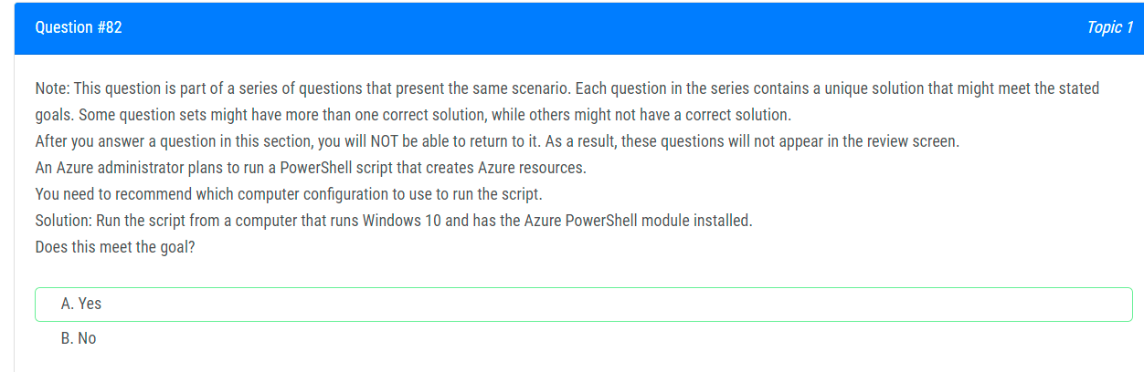
18. 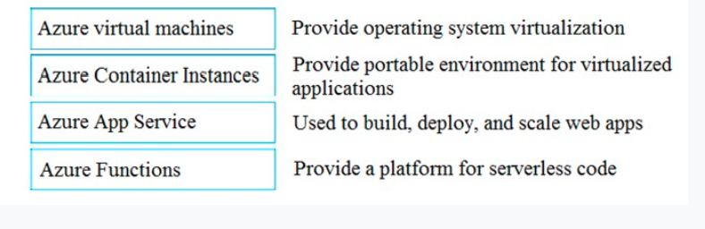
19. 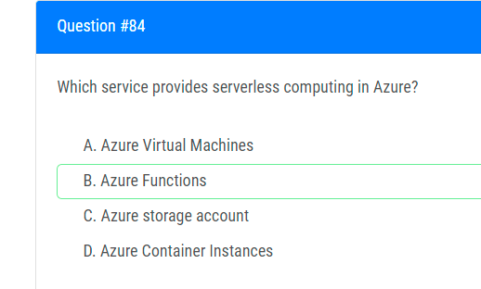
20. 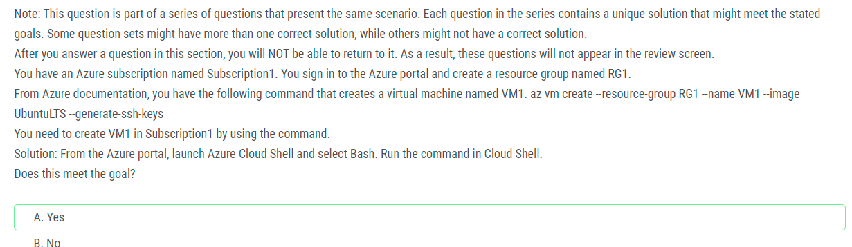
21. 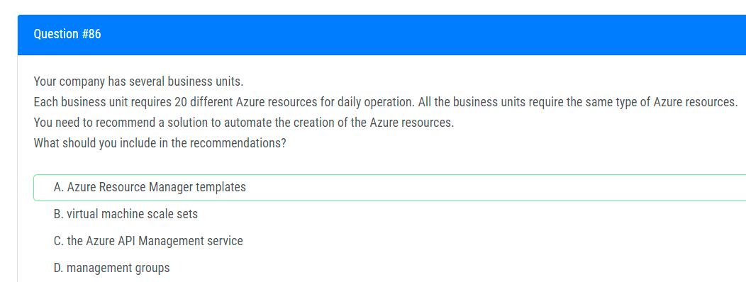
22. 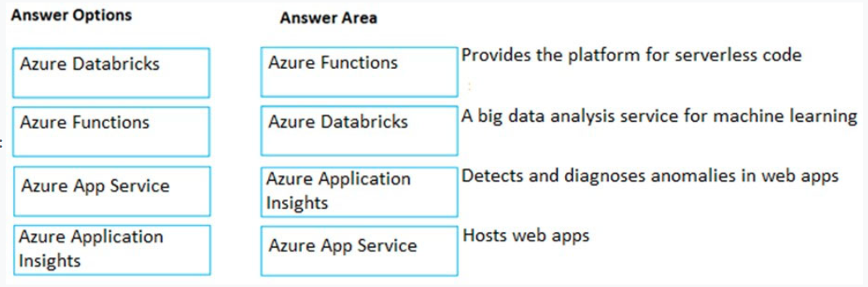
23. 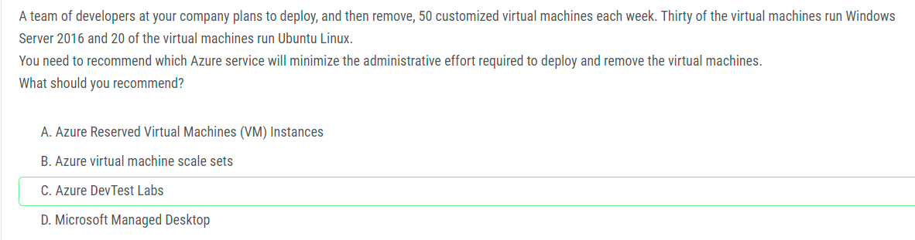
24. 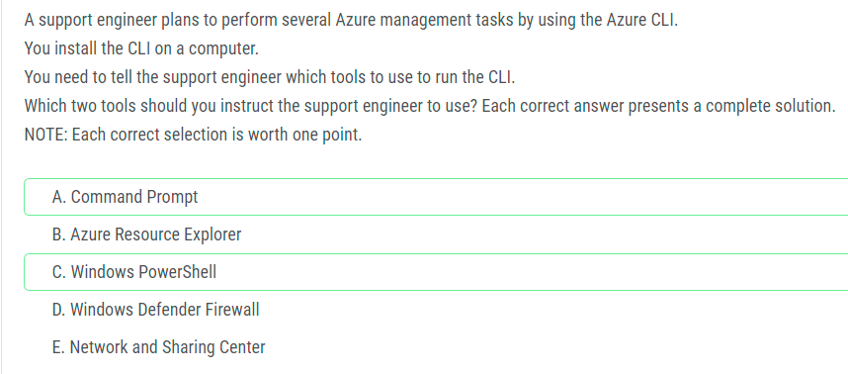
25. 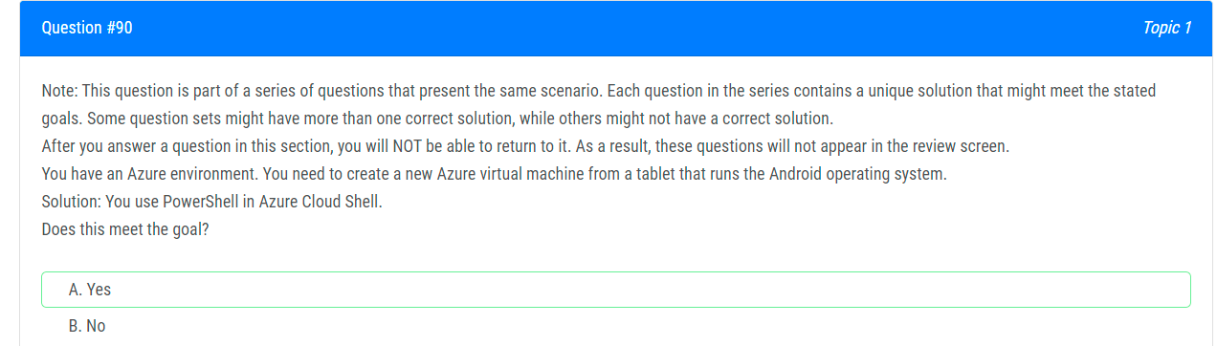
26. 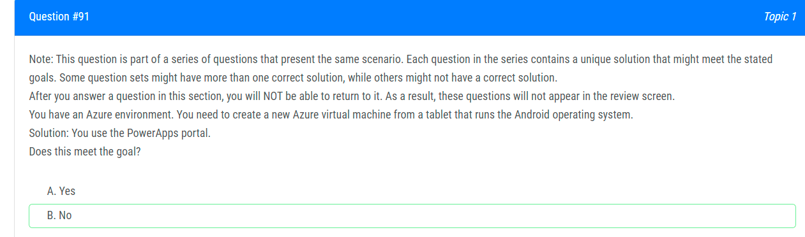PowerApps lets you quickly build business applications with little or no code. It is not used to create Azure virtual machines. Therefore, this solution does not meet the goal.
27. 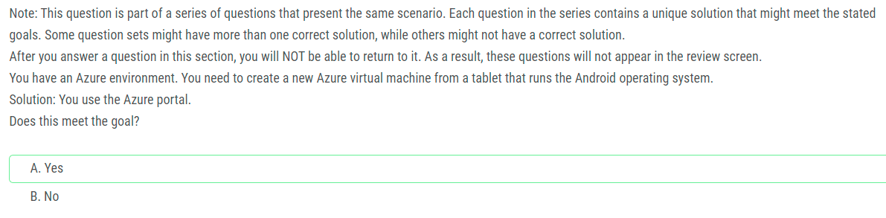
28. 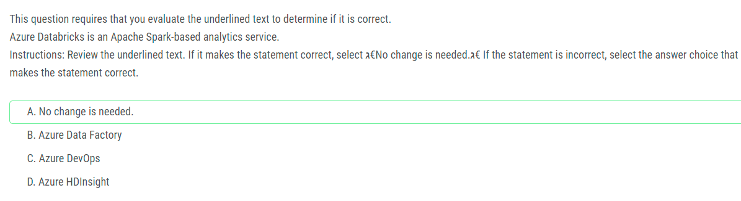
29. 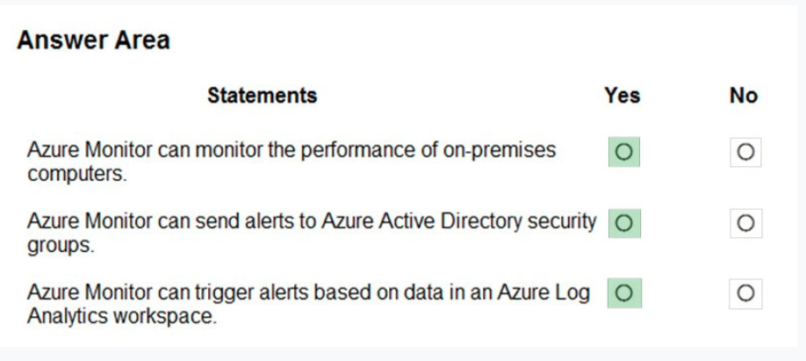
30. 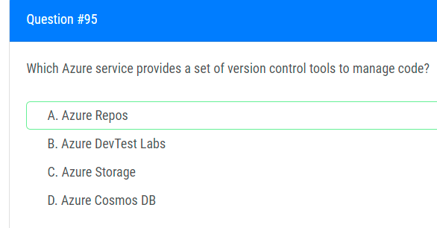
31. 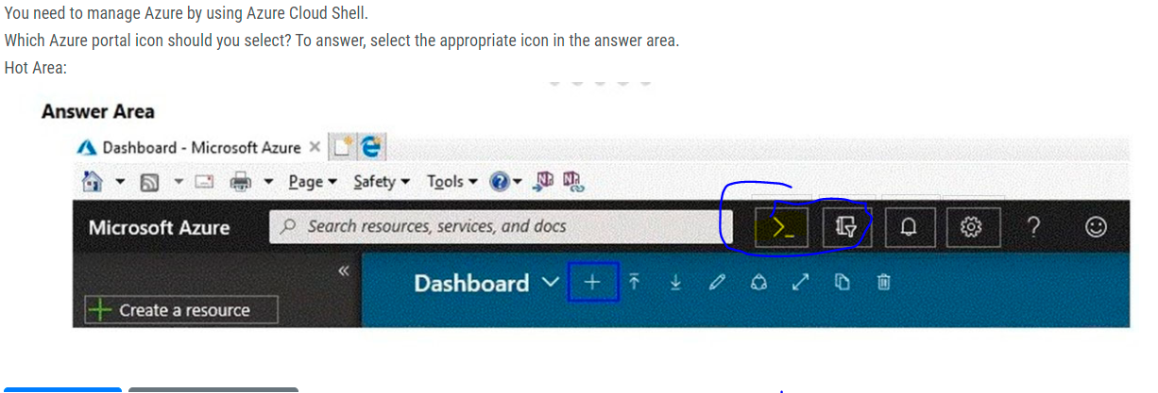
32. 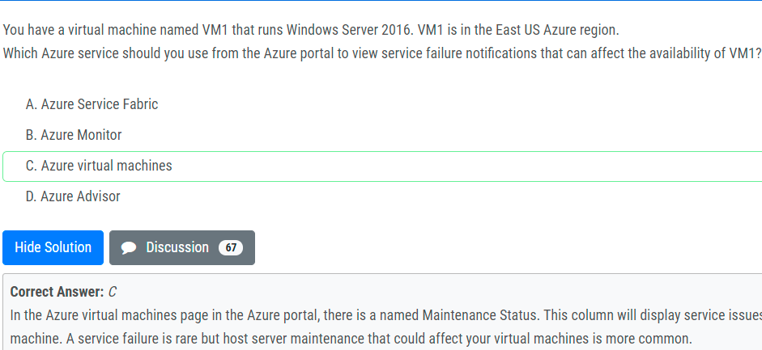
33. 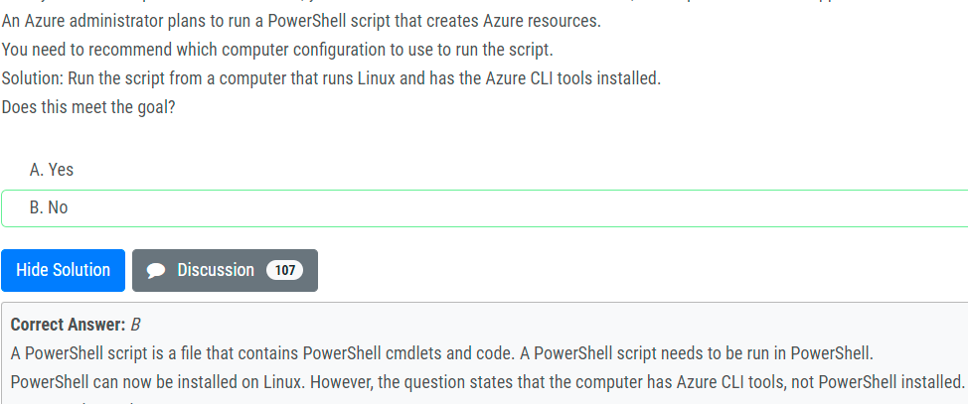
34. 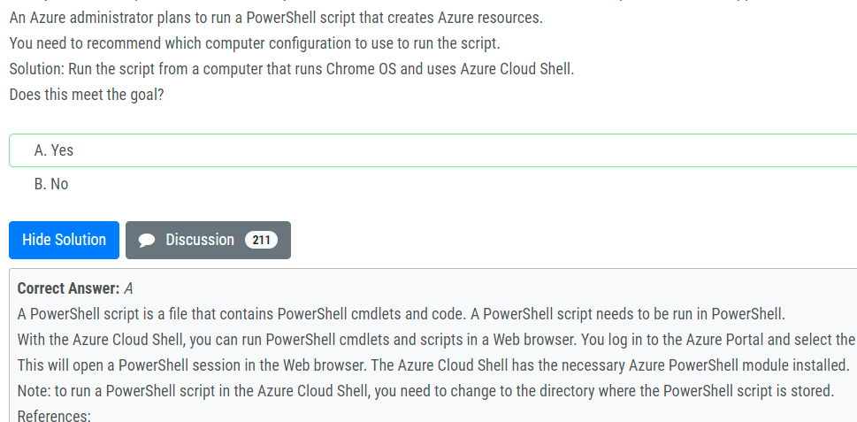
35. 